Experiment no:01 Date:30-09-2020
Aim:To Study fundamentals of operator overloading
Theory:
Operator overloading:C++ has ability to provide the operators with the special meaning for a data type.The mechanism of giving such special meanings to an operator is known as operator overloading.Although the semantics of an operator can be extended, we cannot change its syntax, the grammatical rules that govern its use such as the number of operands,precedence and associativity.when an operator is overloaded, its original meaning is not lost.
To define an additional task to an operator, we must specify what it means in relation to the class to which the operator is applied. This is done with the help of a special function, called operator function, which describes the task.
The general form of operator function is:
return_type class_name :: operator op(argument_list)
{
Function body //task defined
}
Where return_type is the type of value returned by specified operation,op is the operator being overloaded.the op is preceeded by the keyword operator. Operator op is the function name.
Operator functions must be either member functions(non static) or friend functions.
 | Member function | friend function
Unary Operators | No arguments | one argument
Binary Operators | one argument | Two argument
This difference is due to object used to invoke the member function is passed implicitly and therefore is available for the member function .
Argument may be passed either by value or by reference.
The process of overloading involves the following steps:
- Create a class that defines the data type that is to be used in the overloading operation.
- Declare the operator function operator op() in the public part of the class.it may be either a member function or a friend function.
- Define the operator function to implement the required operations.
Overloaded operator functions can be invoked by expressions such as
- For unary operator:op x OR x op which would be interpreted as either operator op(x) for friend functions.
- For binary operator:x op y,which would be interpreted as x.operator op(y) in member functions and operator op(x,y) in friend functions.
When both the forms are declared, standard argument matching is applied to resolve any ambiguity.
If left hand operand which is responsible for invoking member function is not objects of same class then member function will not work in the case only friend function is used in such case.
Manipulation of Strings using Operators: In C++ we can use operators for manipulating the strings .Strings can be defined as class objects which can be then manipulated like the build-in -types. Since the strings vary greatly vary in size, we use new to allocate memory for eacy string and the pointer variable to point to the string array. Thus we must create string objects that can hold these two pieces of information, namely length and location which are necessary for string manipulations.
A typical string class will look as follows:
Class string
{
char *p;//pointer to string
int len;//length of string
public:
……//member functions to intialise and manipulate strings
};
Restrictions for overloading operator
- Only existing operators can be overloaded.new operators cannot be created.
- The overloaded operator must have atleast one operand that is user-defined type.
- We cannot redefined the basic meaning of an operator.
- Overloaded operators follow the syntax of original operators.they cannot be overridden.
- Some operators cannot be overloaded
i)size of operator(sizeof)
ii)Membership operator(.)
iii)pointer-to-member operator(.*)
iv)scope resolution operator(::)
v)conditional operator(?:)
- We cannot use friend function for certain operators
i)Assignment operator(=)
ii)Function call operator(())
iii)Subscipting operator([])
iv)class member access operator(->)
- Binary arithematic operators such as +,-,*, and / must explicitly return a value.they must nt attempt to change their own arguments

1.A)Write a C++ program to understand overloading of unary prefix & postfix operators to perform increment and decrement operations on objects.
#include<iostream>
using namespace std;
class unary{
int i;
public:
unary (){i=0;}
unary(int j)
{
i=j;
}
unary operator ++ ();
unary operator ++ (int j);
unary operator -- ();
unary operator -- (int j);

void display ()
{
cout<<i<<endl;
}
};
unary unary::operator ++()
{
unary temp;
temp.i=++i;
return temp;
}
unary unary::operator ++(int j)
{
unary temp;
temp.i=i++;
return temp;
}
unary unary::operator --()
{
unary temp;
temp.i=--i;
return temp;
}
unary unary::operator --(int j)
{
unary temp;
temp.i=i--;
return temp;
}
int main()
{
unary a;
int num;
cout<<"enter the number to see operations \n";
cin>>num;
unary b(num);
cout<<"a= ";a.display();cout<<"b= ";b.display();
cout<<"prefix increment:a=++b\n";
a=++b;
cout<<"a= ";a.display();cout<<"b= ";b.display();
cout<<"postfix increment:a=b++\n";
a=b++;
cout<<"a= ";a.display();cout<<"b= ";b.display();
cout<<"prefix decrement:a=--b\n";
a=--b;
cout<<"a= ";a.display();cout<<"b= ";b.display();
cout<<"postfix decrement:a=b--\n";
a=b--;
cout<<"a= ";a.display();cout<<"b= ";b.display();

return 0;
}

OUTPUT:

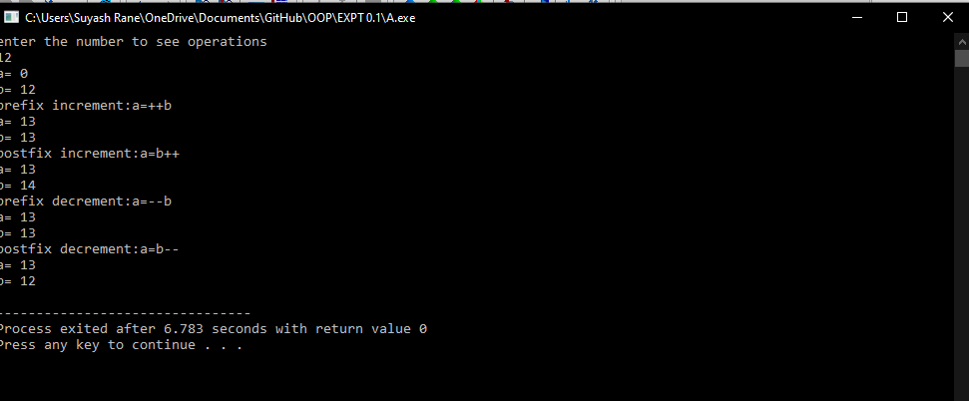

1.B) Write a C++ program to understand overloading of binary operators to perform the following operations on the objects of the class:
#include<iostream>
#include<string>
using namespace std;
class info{
int wardno;
int num;
public:
info()
{wardno=0;num=0;}
info(int w,int n)
{
wardno=w;
num=n;
}
friend istream & operator >>(istream & x,info & y);
friend ostream & operator <<(ostream &x,info y);
};
istream & operator >>(istream & x,info & y)
{
cout<<"Please Enter ward no and no of covid positive persons respectively\n";
x>>y.wardno>>y.num;
return x;
}
ostream & operator << (ostream &x,info y)
{
x<<"WARD NO. : ";
x<<y.wardno;
x<<" No. Of Covid Positive Patients : ";
x<<y.num;
return x;
}

int main()
{
info s1,s2(1,20);

cin>>s1;
cout<<s1<<"\n"<<s2;

return 0;
}

OUTPUT:

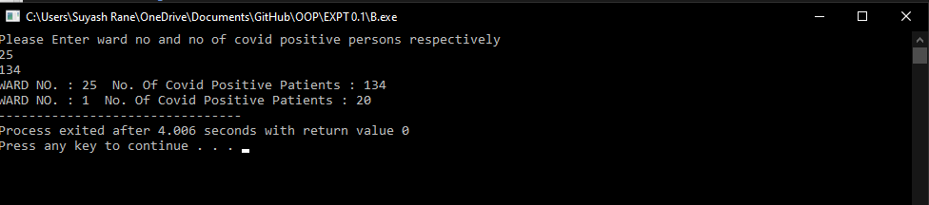

1.C) Write a C++ program to overload binary stream insertion (<<) & extraction (>>) operators when used with objects.
#include<iostream>
using namespace std;
class binary{
int a;
public:
binary(){a=0;}
binary(int x)
{
a=x;
}
binary operator *(binary x);
friend binary operator +(int x,binary y);
binary operator -(int x);

void display()
{
cout<<a;
}
};
binary binary::operator *(binary x)
{
return binary(a*x.a);
}
binary operator + (int x, binary y)
{
return binary(x+y.a);
}
binary binary:: operator -(int y)
{
return binary(a-y);
}
int main()
{
int n1,n2;
cout<<"Enter two numbers on which you want to perform operations\n";
cin>>n1>>n2;
binary X(n1),Y(n2);
cout<<"before operations : ";
cout<<"X=";X.display();cout<<" Y=";Y.display();cout<<"\n";
cout<<"X=5+Y: ";
X=5+Y;
cout<<"X=";X.display();cout<<" Y=";Y.display();cout<<"\n";
cout<<"X=X*Y: ";
X=X*Y;
cout<<"X=";X.display();cout<<" Y=";Y.display();cout<<"\n";
cout<<"X=Y-5 :";
X=Y-5;
cout<<"X=";X.display();cout<<" Y=";Y.display();cout<<"\n";
return 0;
}
OUTPUT:

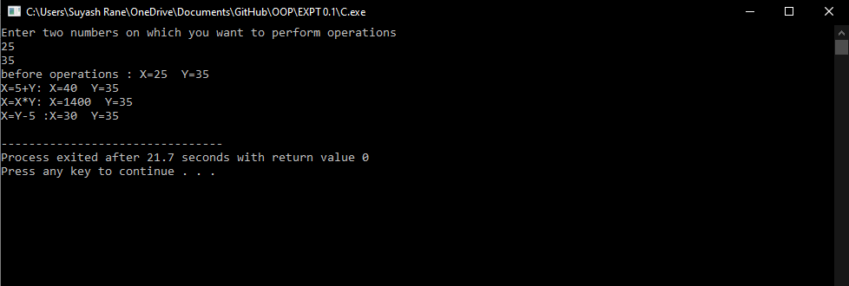

1.D) Write a C++ program using class string to create two strings and perform the following operations on the strings

#include<iostream>
#include<string.h>
using namespace std;
class String
{
char *p;
int len;
public:
String(){len=0;p=0;}
String(const char * S)
{
len=strlen(S);
p=new char[len+1];
strcpy(p,S);
}
String (const String & S)
{
len=S.len;
p=new char[len+1];
strcpy(p,S.p);
}
~String(){delete p; }
friend String operator +(const String & S1,const String & S2);
friend int operator ==(const String & S1,const String & S2);
friend int operator <=(const String & S1,const String & S2);
void display()
{
cout<<p;
}

};
String operator +(const String & S1,const String & S2)
{
String temp;
temp.len=S1.len+S2.len;
temp.p=new char[temp.len+1];
strcpy(temp.p,S1.p);
strcat(temp.p,S2.p);
return temp;
}
int operator ==(const String & S1,const String & S2)
{
if(strcmp(S1.p,S2.p)==0)
return 1;
else
return 0;
}
int operator <=(const String & S1,const String & S2)
{
int m,n;
m=strlen(S1.p);
n=strlen(S2.p);
if(m<=n)
return 1;
else
return 0;
}
int main()
{
String s1("Suyash "),s2("Rane");
cout<<"s1= ";s1.display();
cout<<"s2= ";s2.display();

cout<<"\nAddition operation on strings : ";
String s=s1+s2;
cout<<"\ns= ";s.display();
cout<<"\ns1= ";s1.display();
cout<<"\ns2= ";s2.display();
cout<<"\n";

String s3=s;
cout<<"\nCompare two strings : \n";
if(s3==s)
{
s.display();cout<<" and ";s3.display(); cout<<" are same\n";
}
else
{
s.display();cout<<" and ";s3.display(); cout<<" are not same\n";
}

cout<<"\nCompare the lengths : \n";
if(s1<=s)
{
s1.display();cout<<" is smaller than ";
s.display();
}
else
{
s.display();cout<<" is smaller than ";s1.display();
}

return 0;
}

OUTPUT:

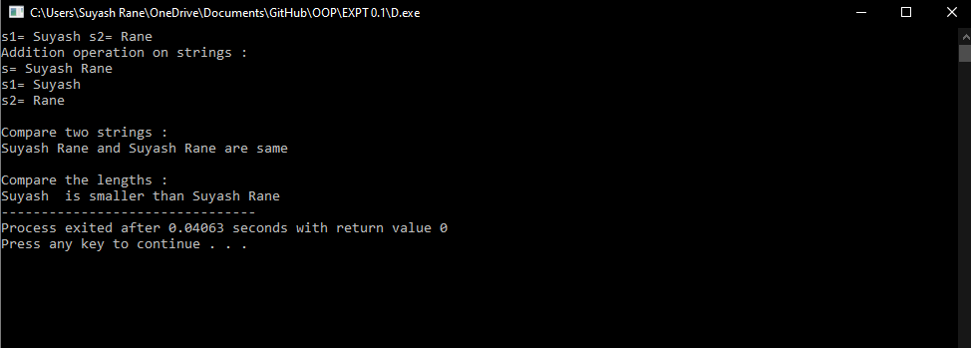

1.E) Write a C++ program to create a vector of ‘n’ elements (allocate the memory dynamically) and then multiply a scalar value with each element of a vector. Also show the result of addition of two vectors.
#include<iostream>
using namespace std;
class vector{
int *v;
int n;
public:
vector(int num);
friend istream & operator >> (istream & in,vector & x);
friend ostream & operator << (ostream & in,vector & x);
friend vector operator * (int x,vector & y);
friend vector operator *(vector & x,int y);
friend vector operator +(vector & x,vector & y);

};
vector::vector(int num)
{
n=num;
v=new int[num];
for(int i=0;i<n;i++)
v[i]=0;
}
istream & operator >> (istream & in,vector & x)
{
for(int i=0;i<x.n;i++)
{
in>>x.v[i];
}
return in;
}
ostream & operator << (ostream & out,vector & x)
{
for(int i=0;i<x.n;i++)
{
out<<"\t"<<x.v[i]<<"\t";
}
return out;
}
vector operator * (int x,vector & y)
{
vector temp(y.n);
for(int i=0;i<y.n;i++)
temp.v[i]=x*y.v[i];
return temp;

}
vector operator * (vector & x,int y)
{
vector temp(x.n);
for(int i=0;i<x.n;i++)
temp.v[i]=x.v[i]*y;
return temp;

}
vector operator +(vector & x,vector & y)
{
if(x.n==y.n)
{
vector temp(x.n);
for(int i=0;i<x.n;i++)
temp.v[i]=x.v[i]+y.v[i];
return temp;
}
else
cout<<"Addition of unequal vectors not possible\n";

}
int main()
{
char *arr;
int num;
cout<<"Enter the number of elements : ";
cin>>num;
vector v(num),v1(num),v2(num),v3(num),v4(num);
cout<<"Enter the elements of v1: ";
cin>>v1;
cout<<"Enter the elements of v2: ";
cin>>v2;
cout<<"v1= "<<v1<<"\nv2= "<<v2;
cout<<"\nv3=2*v1\n";
v3=2*v1;
cout<<"v1= "<<v1<<"\nv3= "<<v3;
cout<<"\nv4=v2*2\n";
v4=v2*2;
cout<<"v2= "<<v2<<"\nv4= "<<v4;
cout<<"\nv=v3+v4\n";
v=v3+v4;
cout<<"v= "<<v<<"\nv3= "<<v3<<"\nv4= "<<v4;
return 0;
}

OUTPUT:

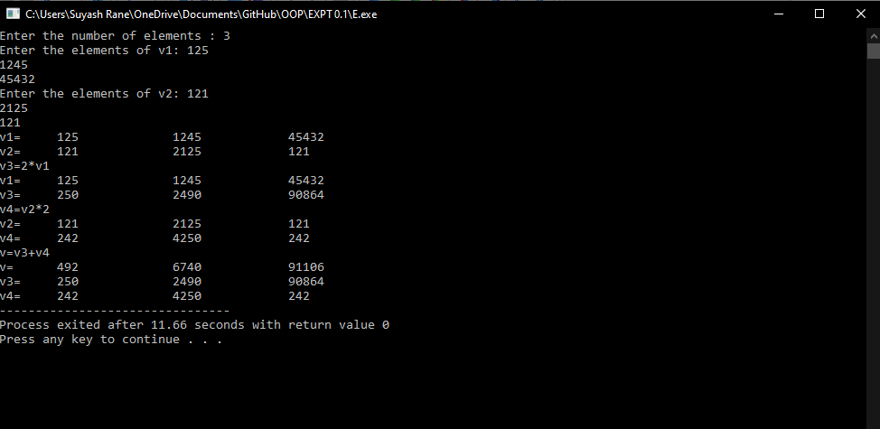

Conclusion:
- Operator overloading is used to give additional meaning to operators.it is used to perform operations on the used defined data types.
- Unary operators, overloaded by means of a member function, take no explicit arguments and return no explicit values, but, those overloaded by means of a friend function, take one reference argument (the object of the relevant class
- Binary operators, overloaded by means of a member function, take no explicit arguments and return no explicit values, but, those overloaded through a friend function take two explicit arguments.
- When left hand operand is not a object of same class member function does not work. Only friend function is used in such case.

